Amazon Work Space
EC2 - Elastic Compute Cloud
Launch an instance
- Name and tags Naming the Instance Select windows OS
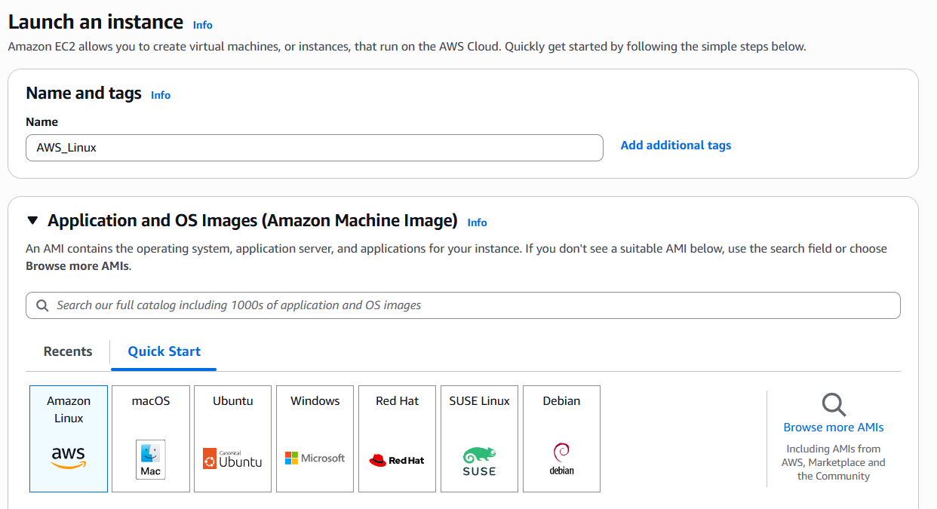

- Selecting instance type (t3.micro)
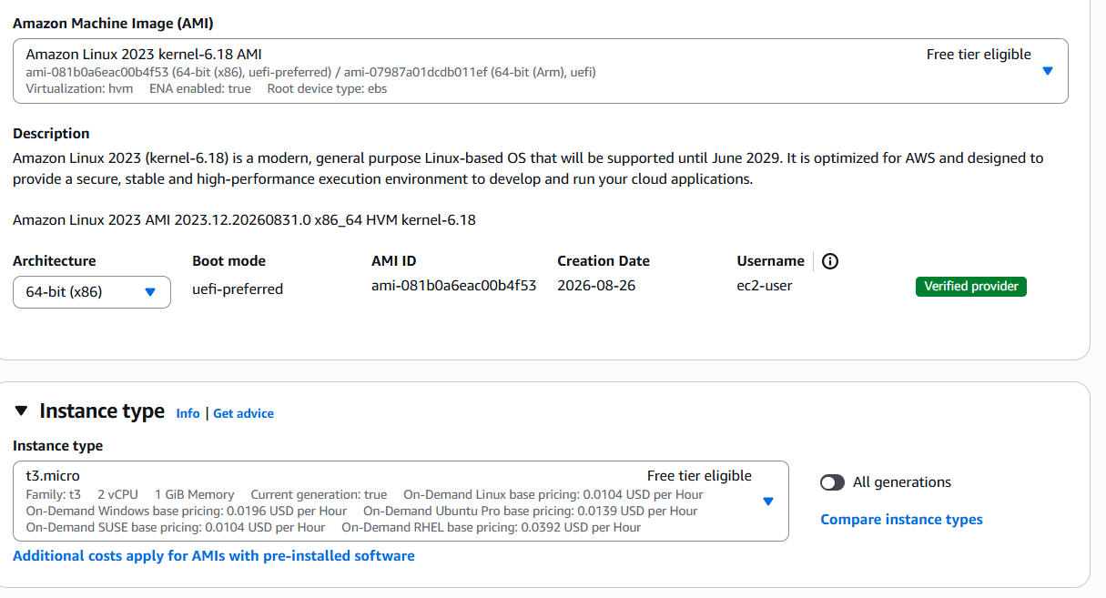
- Key pair (login) Create new key pair

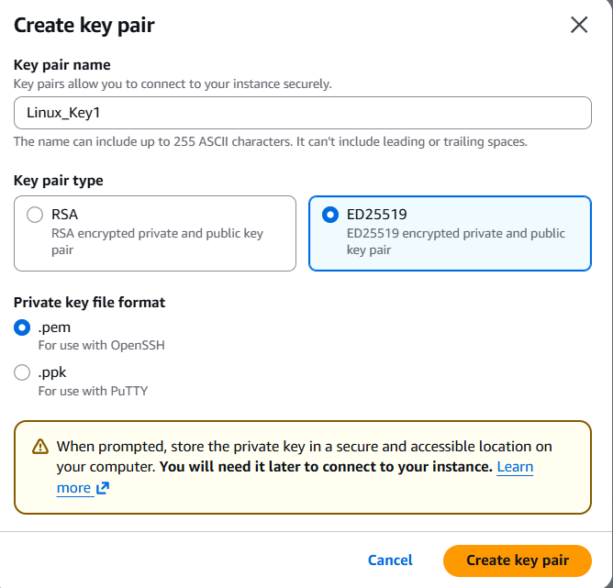

- Network settings Firewall (security groups) Launch an instance
To allow HTTP (port 80) and HTTPS (port 443) traffic in a network setting.
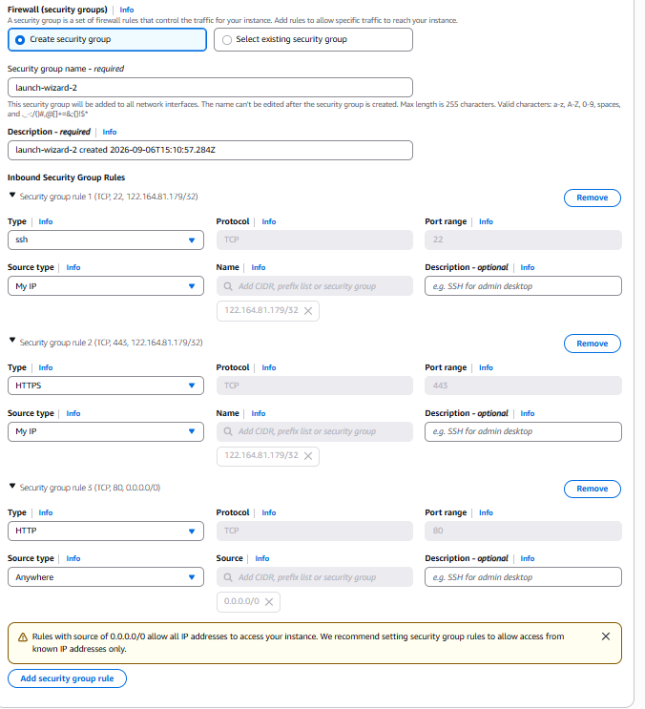
- 3/3 Check passed

- Select the Instance Connect Instance Select EC2 Instance connectConnect.

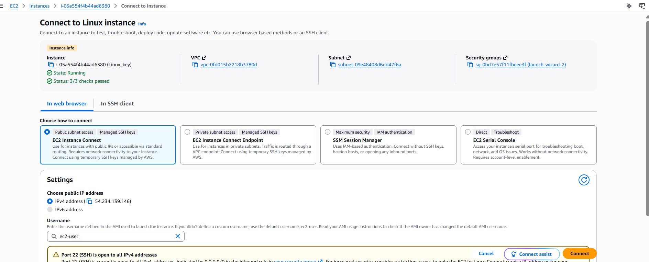

- Connect the Instance

